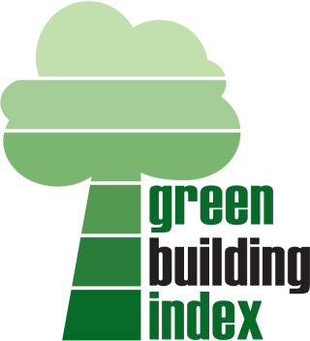
GBI CONSULTATION SESSION
Date : DAY, DD/MM/YY
Time : 9:00 am – 12:00 pm
Venue : Zoom Apps
………………………………………………………………………....
ADMISSION IS FREE [first-come-first-served]
…………………………………………………………………………
PROGRAMME

9:00 am GBI Consultation Session (project by project basis)

12.00 pm End of Session

REGISTRATION FORM
Project Registration No
Project Title
Name
Designation / Job Title |  | GBI Facilitator  Registration No. :  (if applicable)
Company
Address
Phone : |  | Signature  Name:  Date :
Fax : |  | Signature  Name:  Date :
Mobile : |  | Signature  Name:  Date :
Email : |  | Signature  Name:  Date :
No of attendees: |  | Signature  Name:  Date :
* Admission is FREE. Registration is now open to all GBI project applicants and to those who intend to pursue GBI Certification, based on a first-come-first-served basis. Any cancellation must be notified at least two days before the session. The Organizers do not encourage walk-in registrations.
Please EMAIL this form to info@greenbuildingindex.org
* Each session is 30 minutes.

